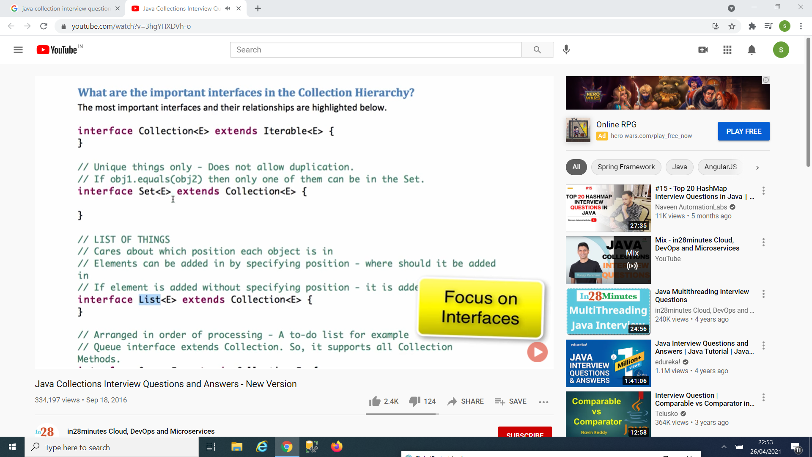

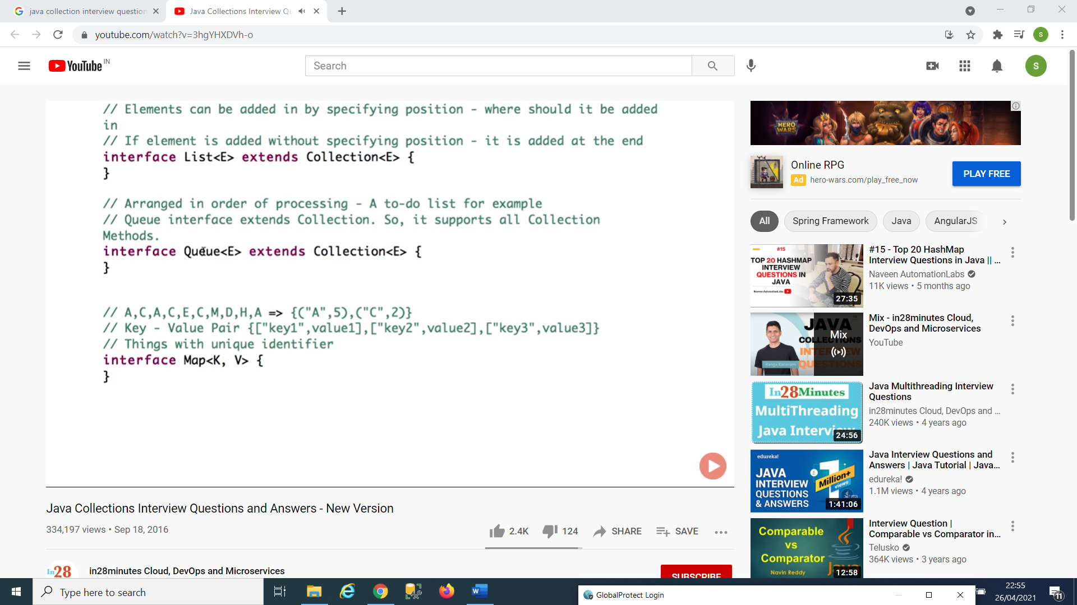

Collection Interface:

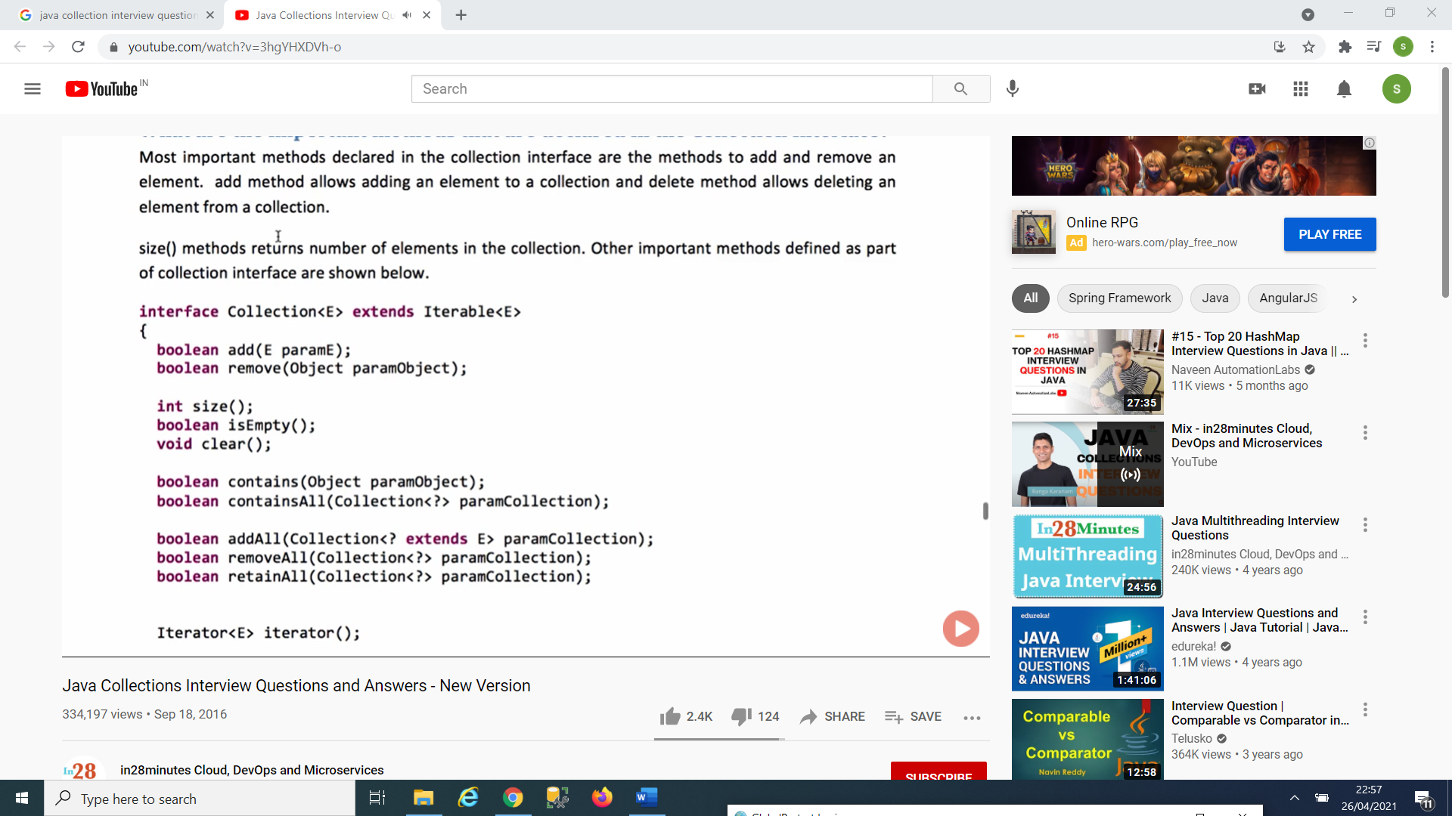

List Interface:

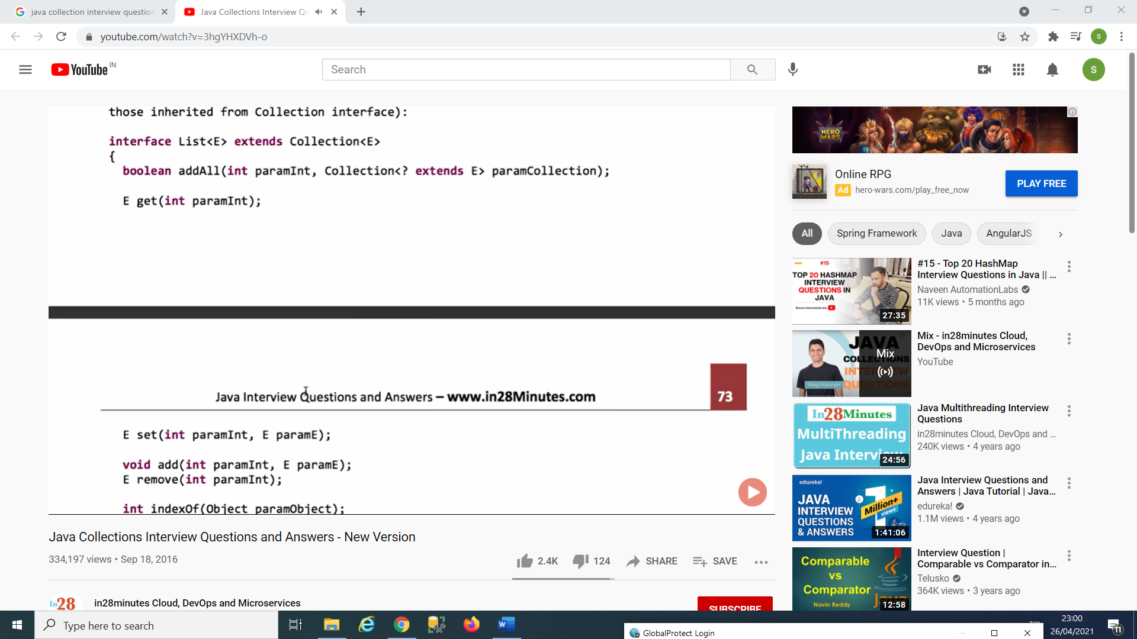

Array List , Vector and LinkedList implements the list.

Set Interface:

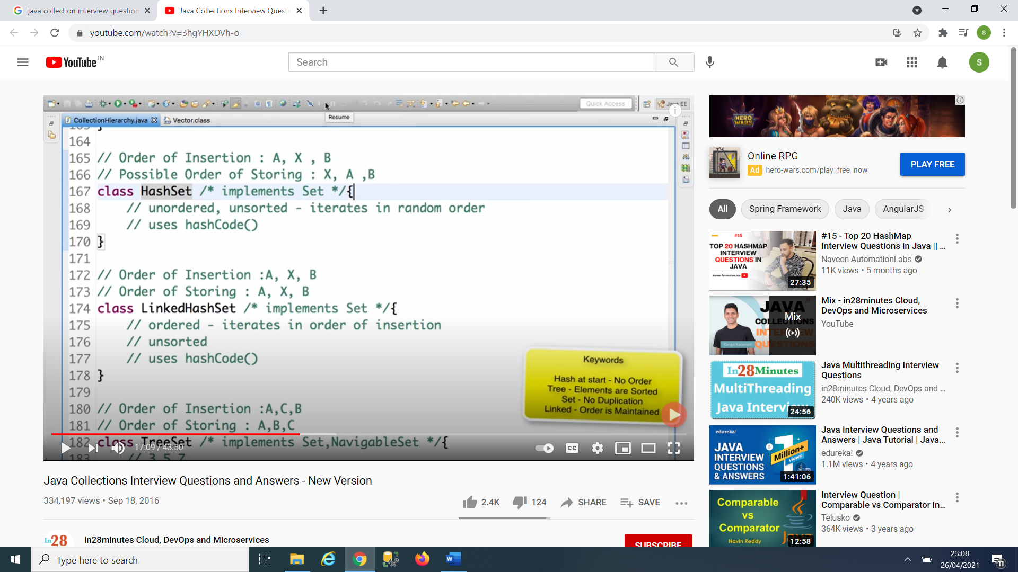

HashSet, LinkedHashSet and TreeSet implements set.

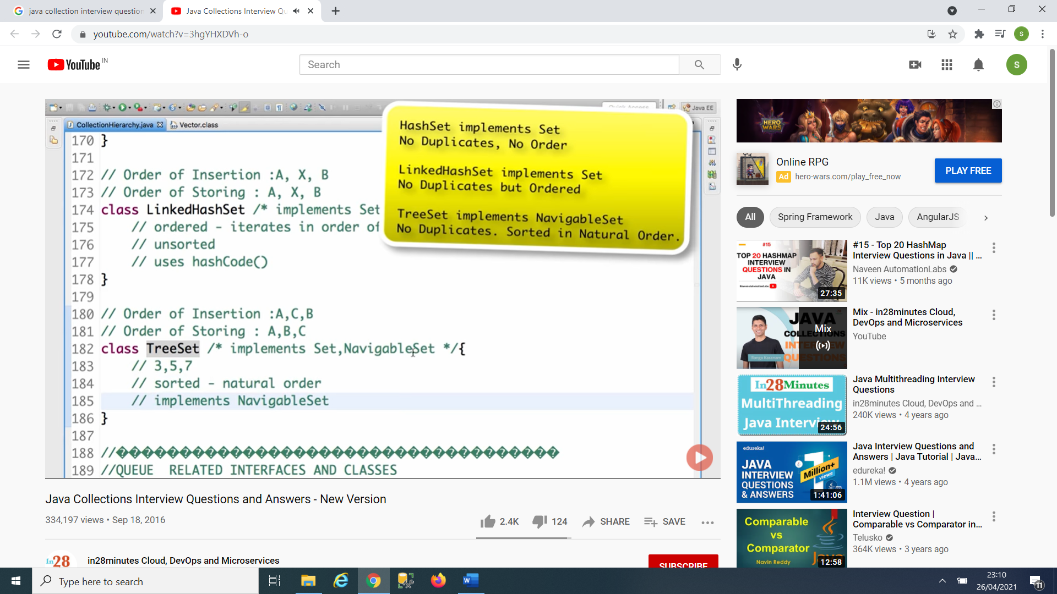

Interface:

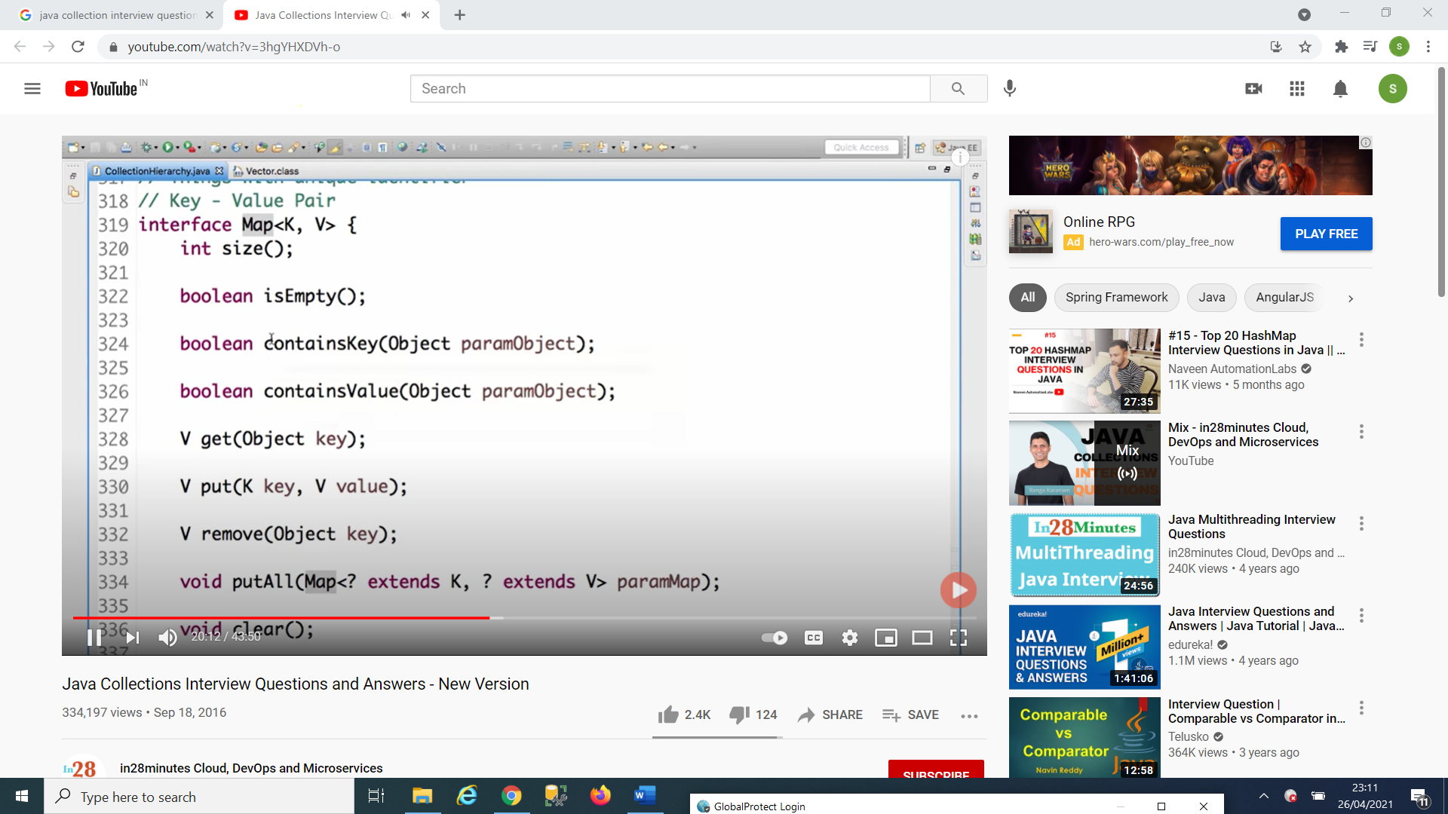



1. How does put() method of HashMap works in Java? 2. What is the requirement for an object to be used as key or value in HashMap? 3. What will happen if you try to store a key which is already present in HashMap? 4. Can you store a null key in Java HashMap? 5. Can you store a null value inside HashMap in Java? 6. How does HashMap handle collisions in Java? 7. Which data structure HashMap represents? 8. Which data structure is used to implement HashMap in Java? 9. Can you store a duplicate key in HashMap? (answer) 10. Can you store the duplicate value in Java HashMap? (answer) 11. Is HashMap thread-safe in Java? 12. What will happen if you use HashMap in a multithreaded Java application? 13. What are the different ways to iterate over HashMap in Java? 14. How do you remove a mapping while iterating over HashMap in Java? 15. In which order mappings are stored in HashMap? 16. Can you sort HashMap in Java? (answer) 17. What is the load factor in HashMap? A load factor is a number that controls the resizing of HashMap when a number of elements in the HashMap cross the load factor as if the load factor is 0.75 and when becoming more than 75% full then resizing trigger which involves array copy. 18. How does resizing happens in HashMap? (answer) 19. How many entries you can store in HashMap? What is the maximum limit? 20. What is the difference between the capacity and size of HashMap in Java? 21. What will happen if two different keys of HashMap return the same hashcode()?

**How HashMap Work**?

Its works on hashing the key of hashmap provided at the time of inserting any value to hashmap.

For Hashing hashmap override hashCode method which is coming from Object class.

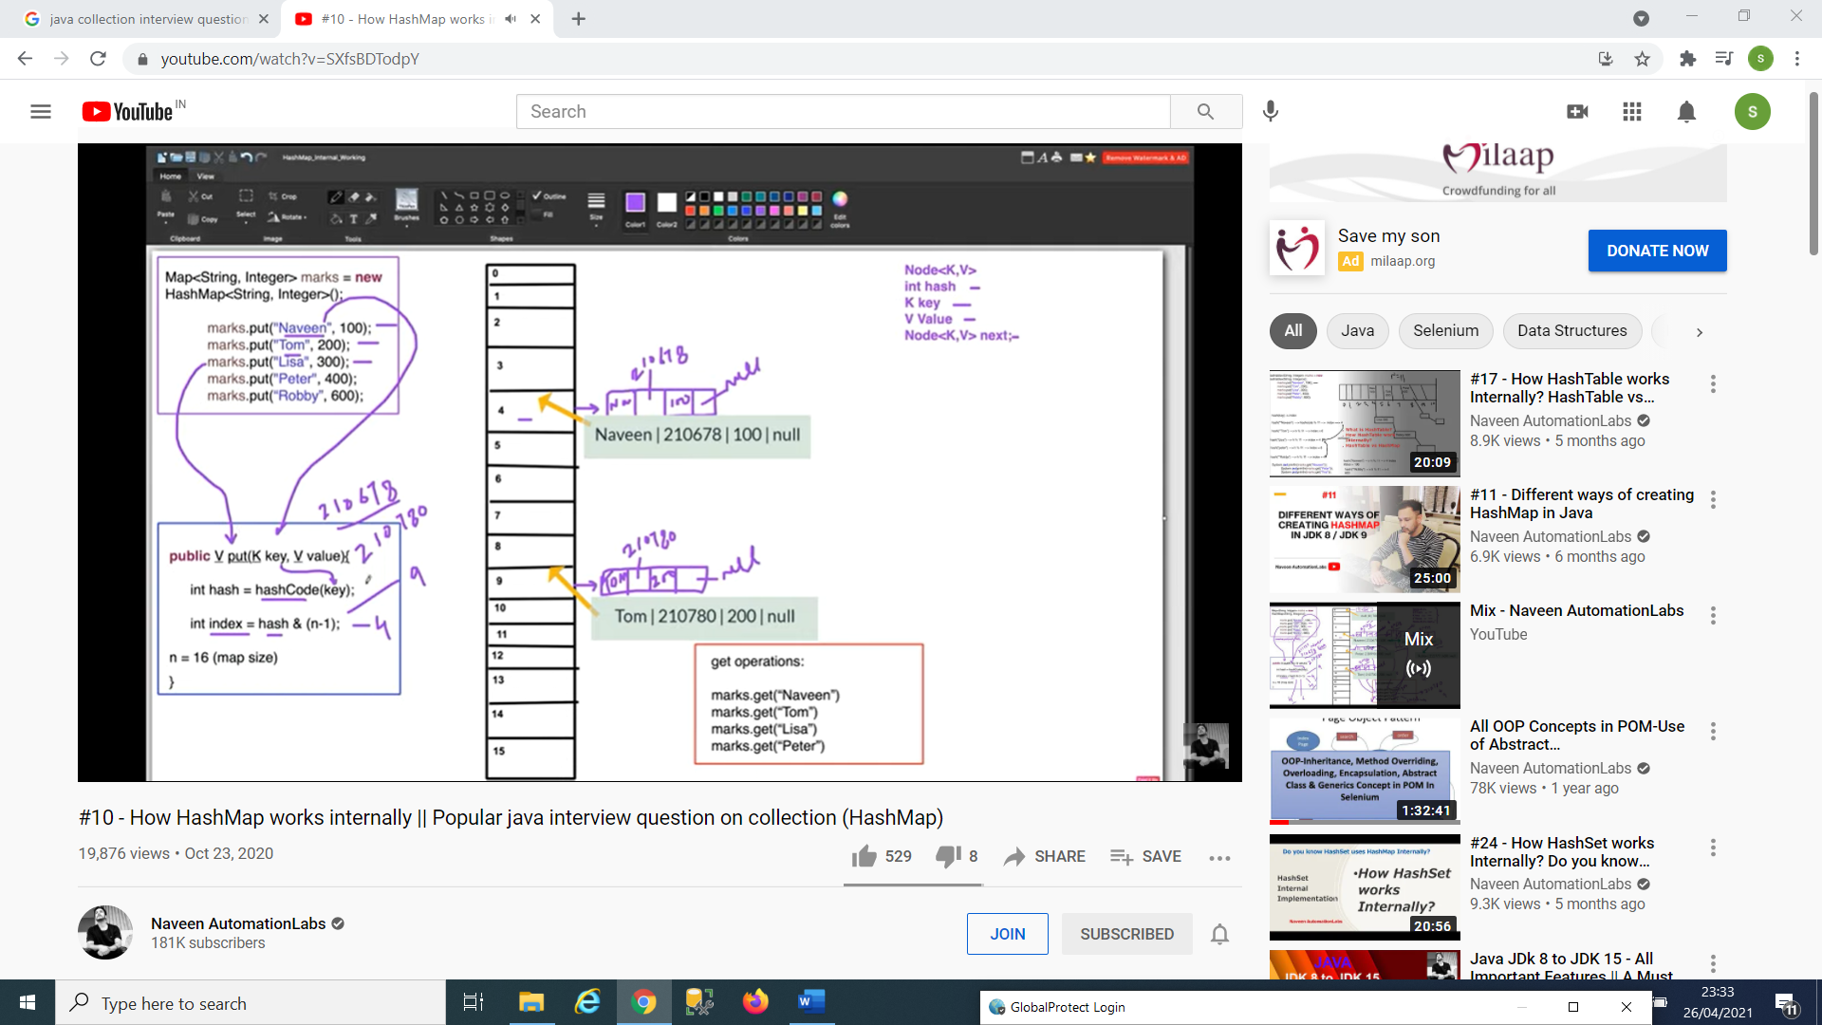

When we are having the same hashcode or index then (Hashing collision)

It use the. equals method to check that the key value ..if it is equal then it will return the value

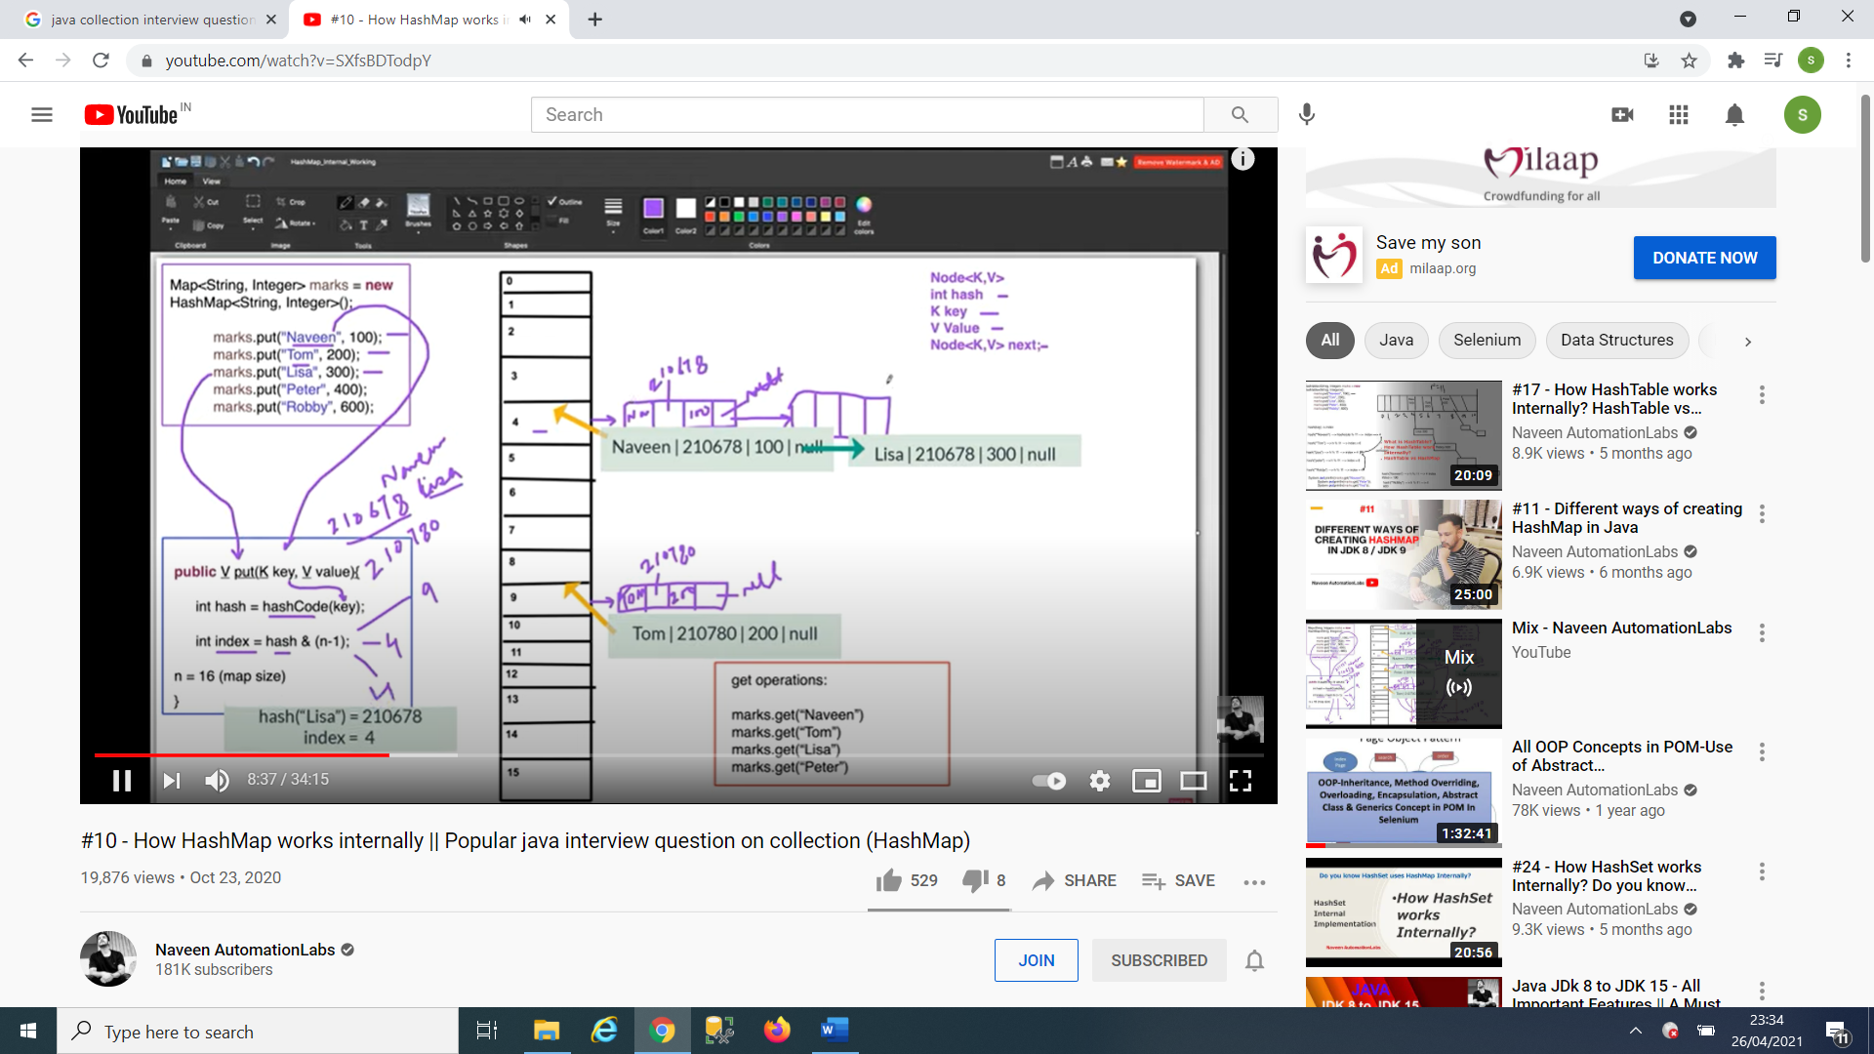

**When the key Value is null:**

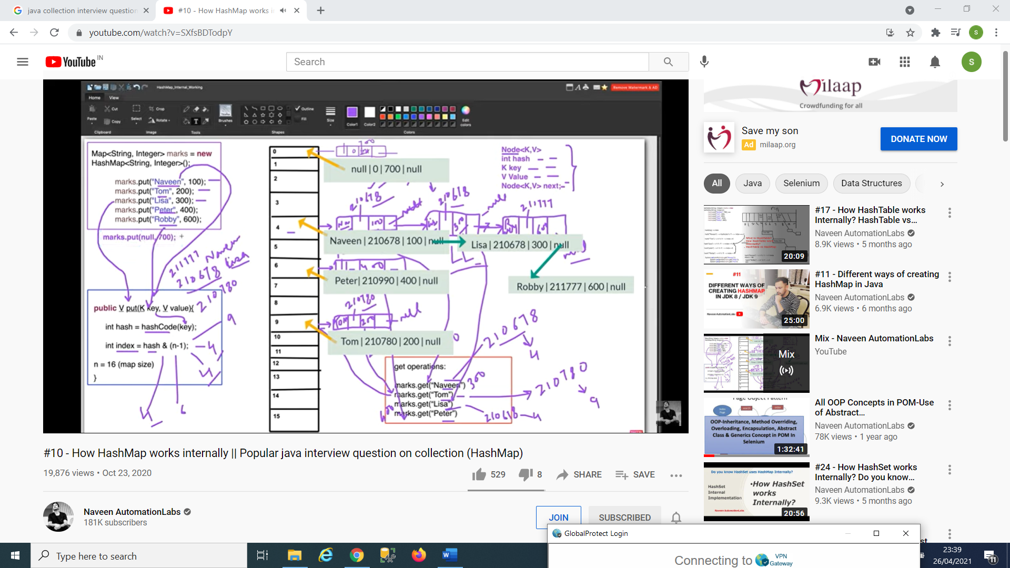

**After 1.8 :**

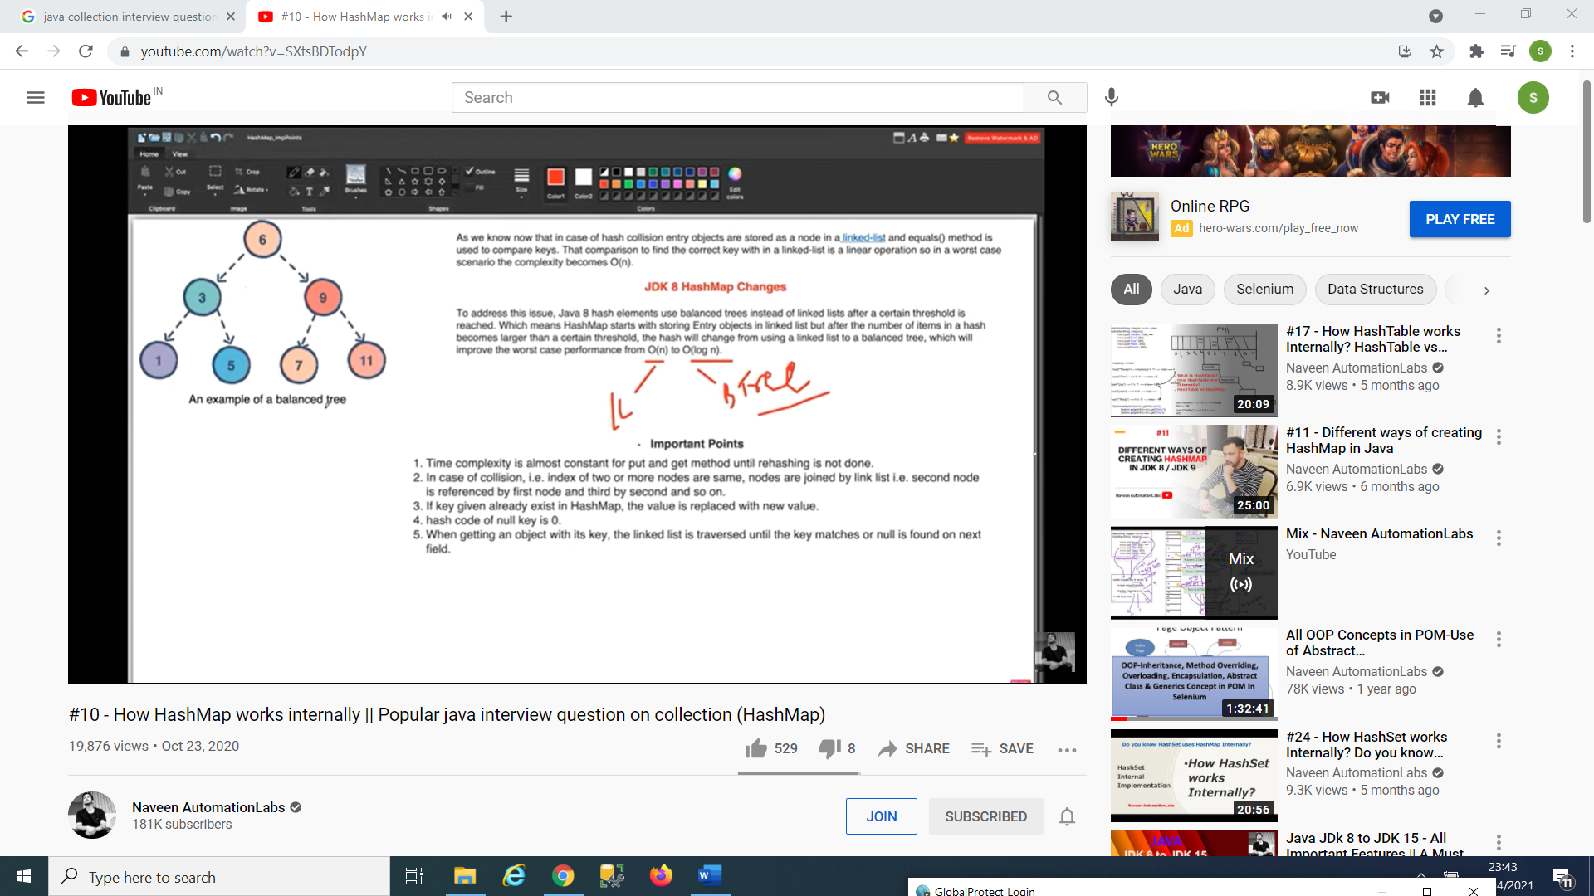

**How HashTable works?**

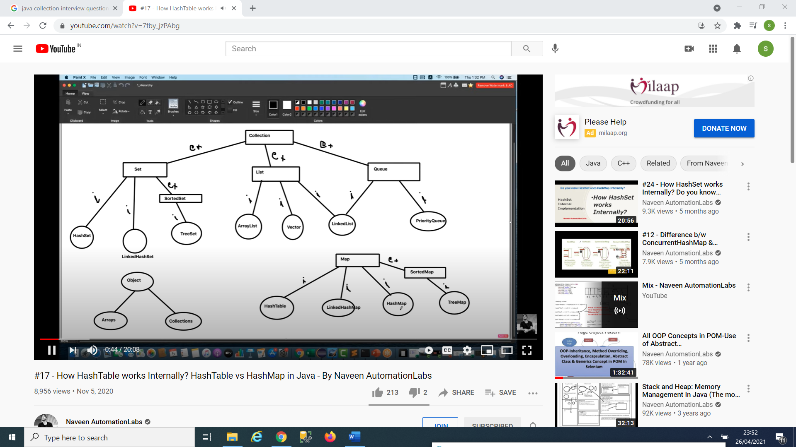

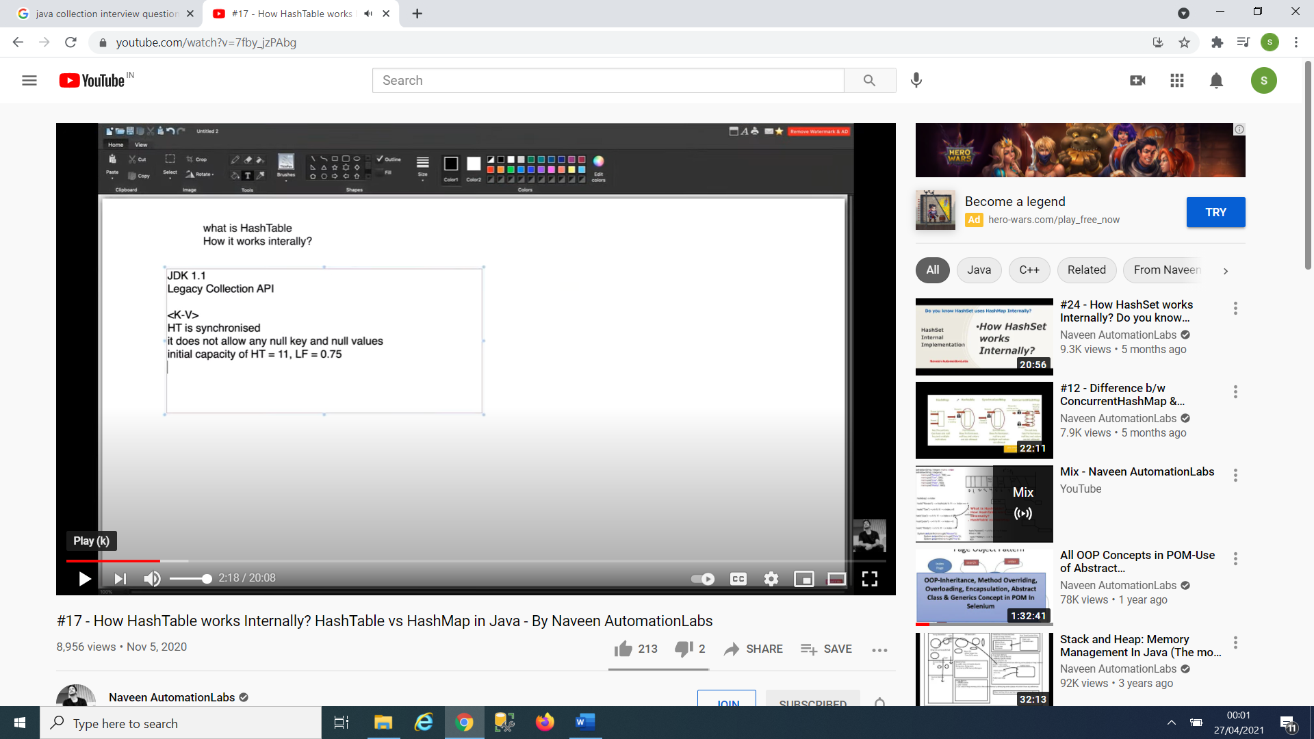

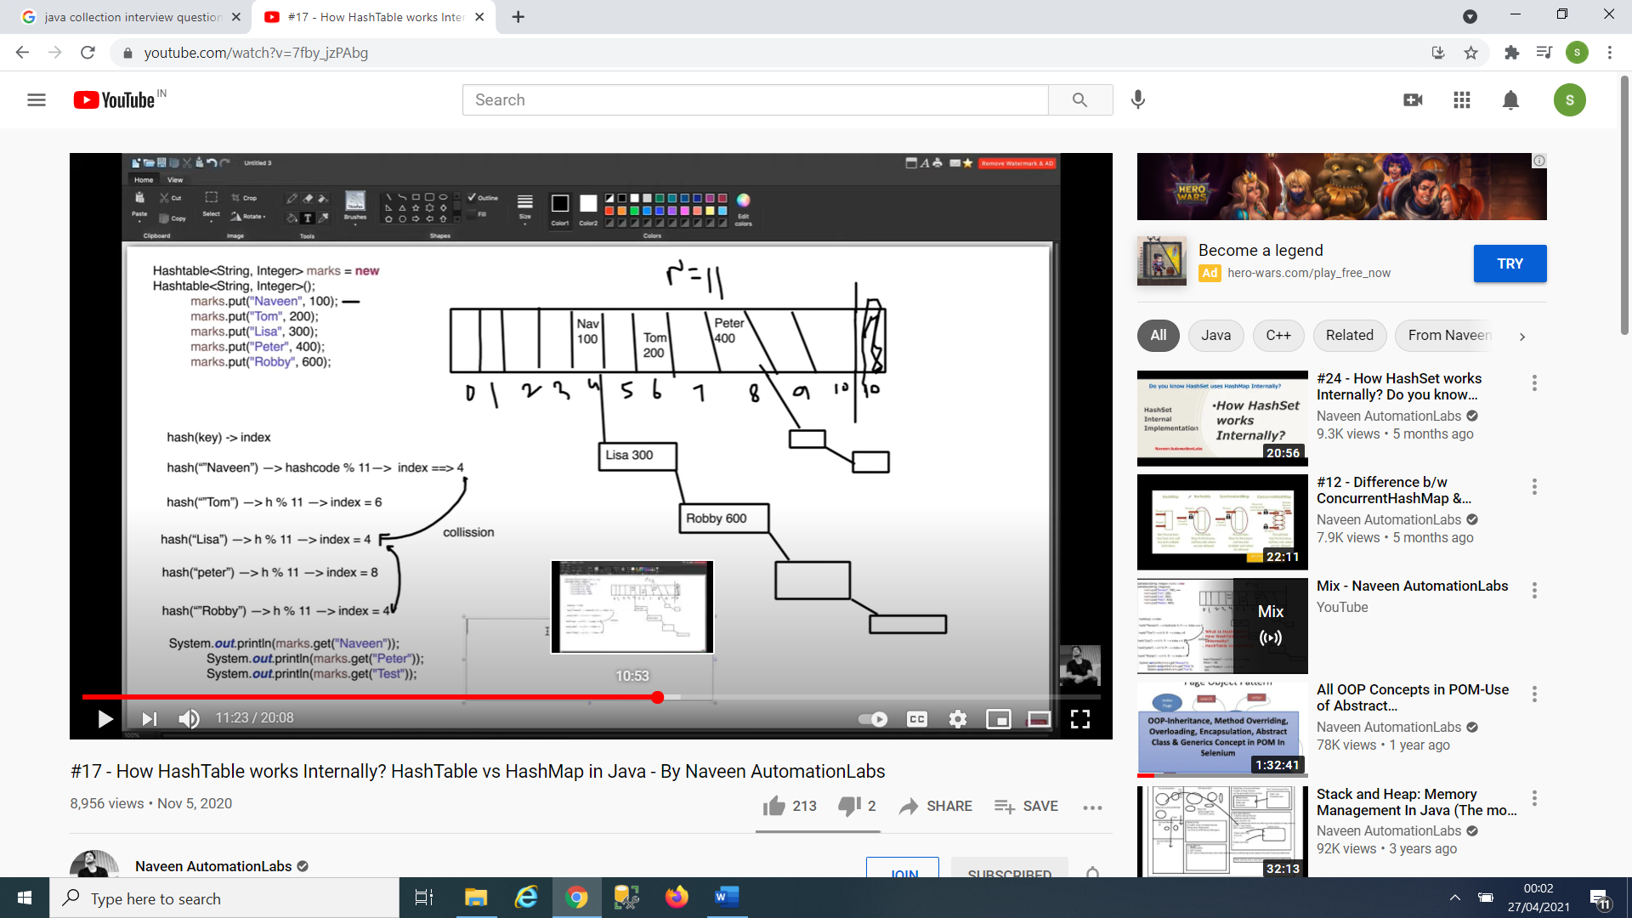

**Debug mode :**

